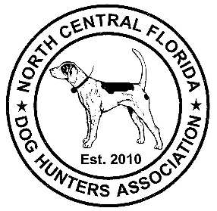 | North Central Florida  Dog Hunters Association  To Preserve The Tradition Of Dog Hunting

☐ Annual Membership Fee $25

☐ Extra Donation Amount $_________

Applicant Information
Full Name:
 | Last | First | M.I.
Address:
 | Street Address |  | Apartment/Unit #
 | City | State | ZIP Code
Telephone: | ( ) | County of Residence :

Email address:

Dog Hunting Interest – Check all that apply
☐ Deer | ☐ Fox | ☐ Coyote | ☐ Cat
☐ Hog | ☐ Rabbit | ☐ Raccoon | ☐ Other:_____________

Please send completed application and a check to:

North Central Florida Dog Hunters Association
1404 Holt Rd.
Perry, Florida 32348

